Our project is a Face Recognition-Based Attendance System designed for efficient and accurate student attendance tracking. Instead of traditional methods like manual roll calls or RFID cards, our solution automates attendance using facial recognition technology.

How It Works:

1. Image Registration – Users can upload their images to the system, storing them in a database.
2. Face Recognition – The system captures live video, detects faces, and compares them with stored images using DeepFace (Facenet model).
3. Attendance Marking – If a match is found with 60% or higher similarity, attendance is recorded in

a CSV file with the date and time.

1. Live Name Display – The recognised person's name is displayed on the camera feed in real time.
2. User-Friendly Interface – The system includes a simple Tkinter GUI to upload images, start/stop

the camera, and view attendance records.

Opportunities

How Different Is It from Existing Ideas?

* + Unlike manual attendance (time-consuming, error-prone) or RFID systems (cards can be lost or misused), our system automates attendance with face recognition, reducing human intervention.
  + Compared to existing face recognition systems, our solution is lightweight and optimized for performance, making it

suitable for low-end PCs ("potato PCs").

* + Uses DeepFace (Facenet model), which is more accurate and faster than traditional OpenCV-based recognition.

How Does It Solve the Problem?

* + Eliminates proxy attendance – Since face recognition is unique, students cannot mark attendance for others.
  + Reduces teacher workload – No need for manual roll calls; attendance is recorded automatically.
  + Time-efficient – Attendance marking is done in seconds, improving classroom efficiency.
  + Easy Tracking – Attendance is stored in a CSV file that can be accessed anytime for records.

Unique Selling Proposition (USP)

* + Fast Face Recognition – Processes faces in real-time with minimal lag.
  + Optimized for Low-End PCs – Works efficiently even on basic hardware.
  + User-Friendly GUI – Simple interface using Tkinter for easy operation.
  + Attendance Recorded Once per Session – Avoids duplicate entries, ensuring accuracy.
  + Easy Image Uploading – New students can be added with a simple image upload.

List of features offered by the solution

* + - Automated Face Recognition
    - Attendance Marking & Storage
    - User-Friendly Interface (GUI)
    - Image Upload & Student Database
    - Optimized for Performance
    - Attendance Viewing & Management

Process flow diagram or Use-case diagram

Teachers upload the students images with roll number in the database

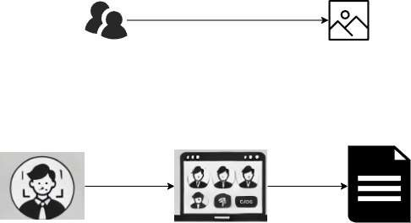

When student is identified in scan the attendance

take as present and generate a csv file with present list

Architecture diagram of the proposed solution

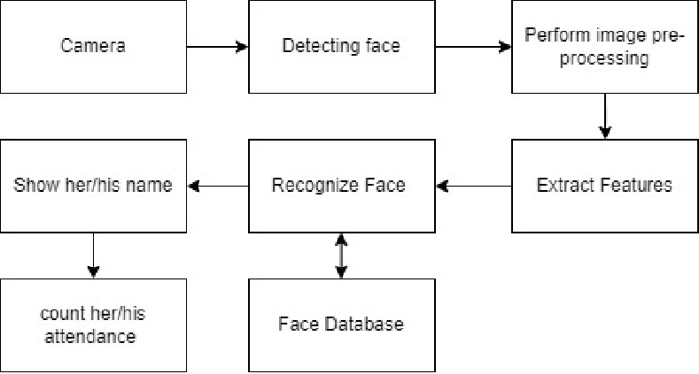

Technologies to be used in the solution

* + - Programming language: Python
    - Graphical User Interface (GUI): tinker
    - Computer Vision & Face Recognition: opencv, deepface
    - Data Storage & Management: pandas, csv, os module
    - Threading & Performance Optimization: Threading Module
    - File Handling & Data Processing: PIL, Subprocess Module